**OVERVIEW**

Digital Asset Management is a core technology and a critical infrastructure component for Customer Experience. From creation to consumption, OpenText™ Media Management provides a “single source of truth” and consolidated asset repository for marketing, branding, commerce, video and global distribution. It’s an integral part of an ecosystem with interconnected and interdependent contributors and production environments (such as agencies, photo, video, audio, graphics, layout) provisioning digital media content for the multi-channel digital supply chain, digital operations, marketing and brand management. This document contains a quick overview of Media Management’s version 20.4 interface.

**HOME PAGE**

The “Home Page” viewed below includes:

1) Hamburger Menu: Expand or contract side menu item description.

2) Widget Settings/Home Screen: User defined widgets and Size options for the tiles.

3) Assets: Various search categories appear. After search selection, the Assets page displays the search results.

4) Folders: The folder tree for private and public folders.

5) Collections: The collections of assets appear. After applying refined search filters, displays the search results.

6) Jobs: The Job Center listing of all your upload, export jobs and custom workflows interaction.

7) Checked out: A listing of the assets you have checked out.

8) Reporting Express (Supplied by EIX): Dashboard Reporting that can be exported for System, Timing and Predictive Disk Usage.

9) AMP (Supplied by EIX): Accelerated Manifest Processor - Import, Update or Attaching Bulk Assets via a Spread Sheet.

10) Search Bar: Use this to search for assets.

11) Upload: Use this to import assets.

12) Recent Jobs: Displays the list of the recent jobs performed.

13) Help: Opens webpage to an online topic and help document.

14) User Profile: Allows for view preferences and application logout.

15) Add Widget: Add a new widget for a Folder, Collection etc., by hovering over the empty tile and clicking ‘Add New’.

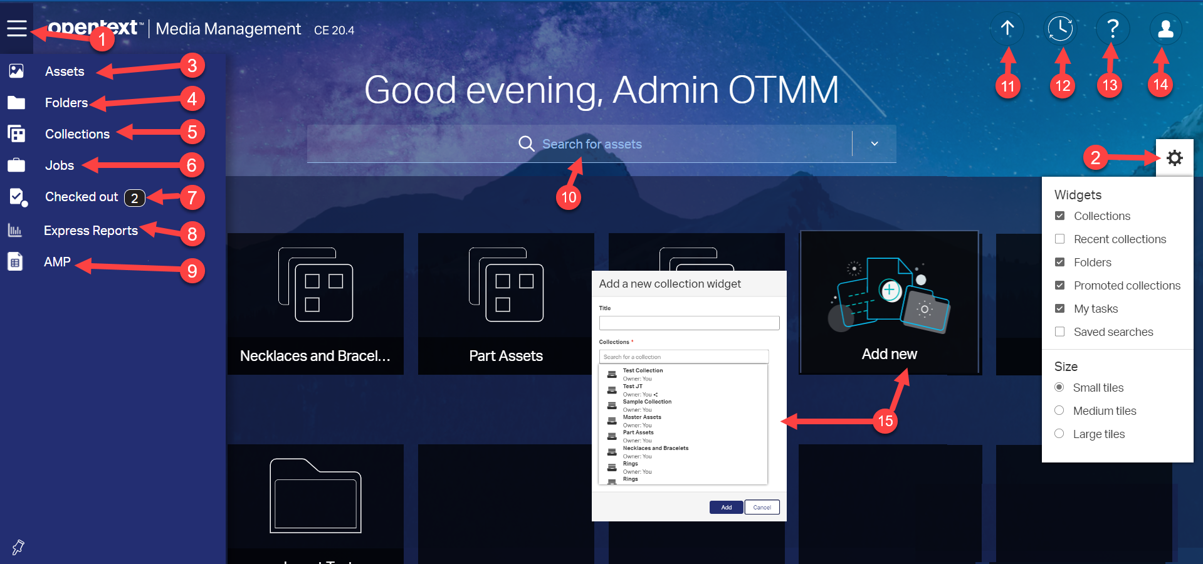

**WORKING WITH ASSETS**

Some of the actions a user can do from a results page by selecting or by hovering over an asset include:

1) Direct download an asset to your machine.

2) Direct download a preview of an asset.

3) Custom download an asset by specifying the Delivery Format, Asset Format and Asset Resolution.

4) Sharing asset allows for transformation of singular or multiple assets with various forms of delivery.

5) Copies the link of an asset to your clipboard.

6) An asset’s properties, also called metadata, can be modified in OTMM, one asset at a time or multiple assets can be edited at once in a bulk edit.

7) When you are subscribed to an asset, you will receive an email when another user edits its properties, checks in a new version, or deletes the asset.

8) You can add assets to an existing collection or to a newly created collection.

9) Creates a Job, and then creates Tasks which they assign team members who are participating in the Job.  Job can be an approval process or annotated if users have Creative Review.

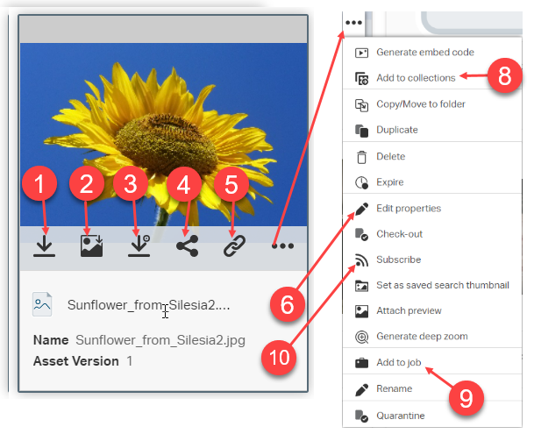

Clicking on a thumbnail will preview the asset and reveal its properties.

Various metadata fields or properties associated with assets and folders include: Simple text fields, Date fields, Domain fields, Type-ahead domain fields and Cascading fields. As an option, the solution also has connections to the Azure AI which can automatically populate metadata, speech to text or OCR for images and videos.

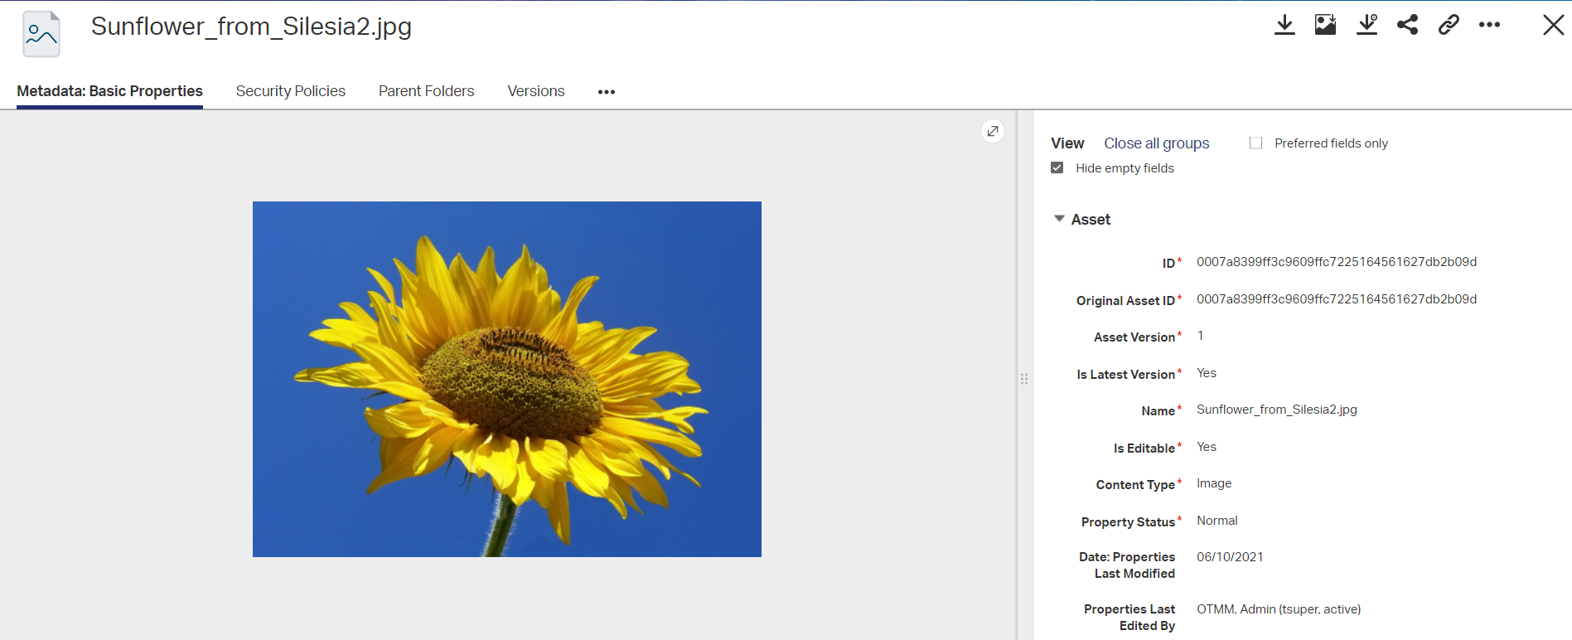

Media Manager enables users to create, review, and delete links, or relationships, between assets. When linking assets together, you specify a relationship type, using specific terms like “belongs to” or “is-parent-of”, when relating a source asset to a destination asset. The destination asset is the asset to which the source asset is linked to. In other words, the associations are directional, and originate from the source asset to the linked asset.

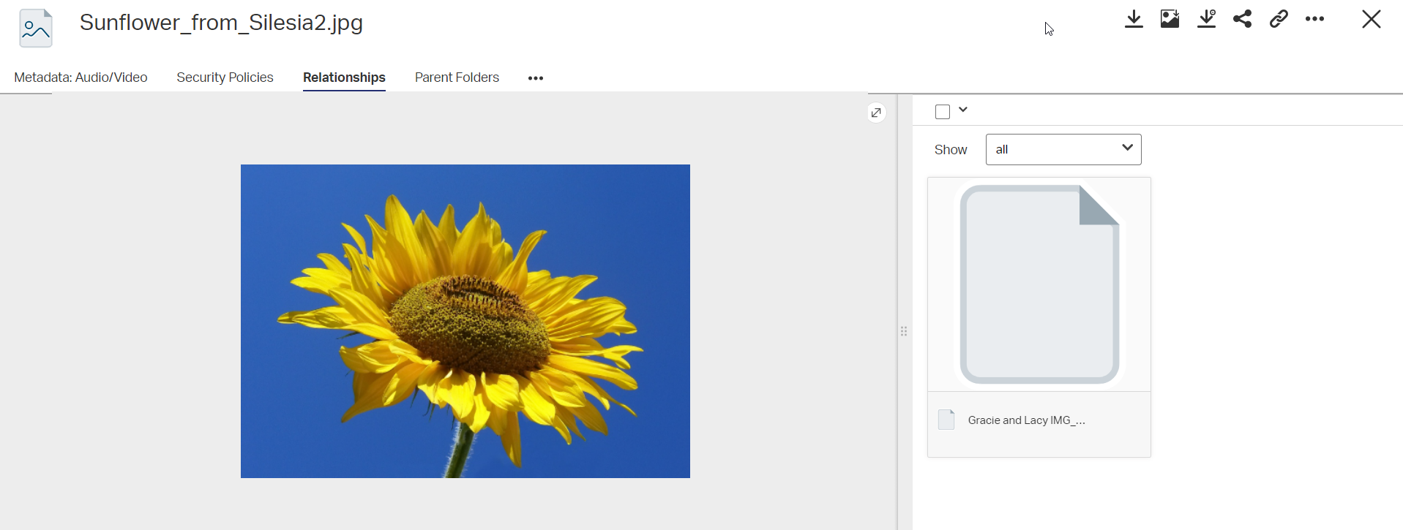

You can check out the latest version of assets to edit them. When you check out an asset, OTMM locks that asset to prevent other users from overwriting its contents. OTMM keeps the previous version of the asset as well as the new modified version.

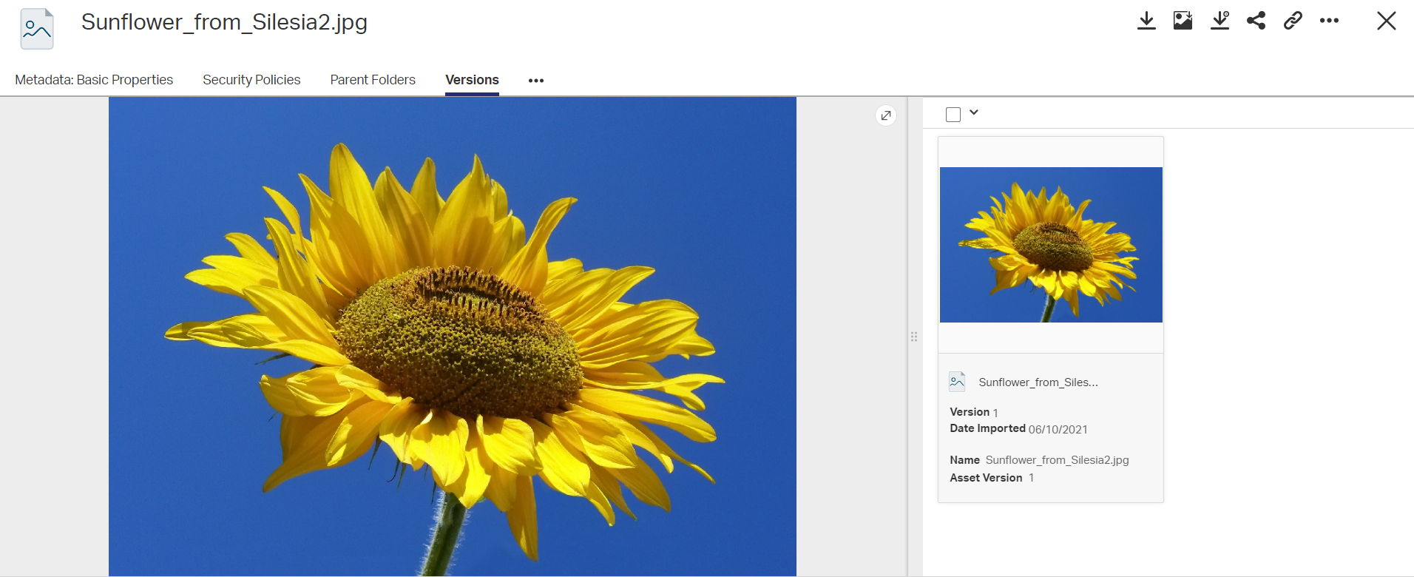

With Jobs, Simple or Creative Review provide a comprehensive media review process management that includes annotation, markup, and approval capability for documents, images, audio, and video.  

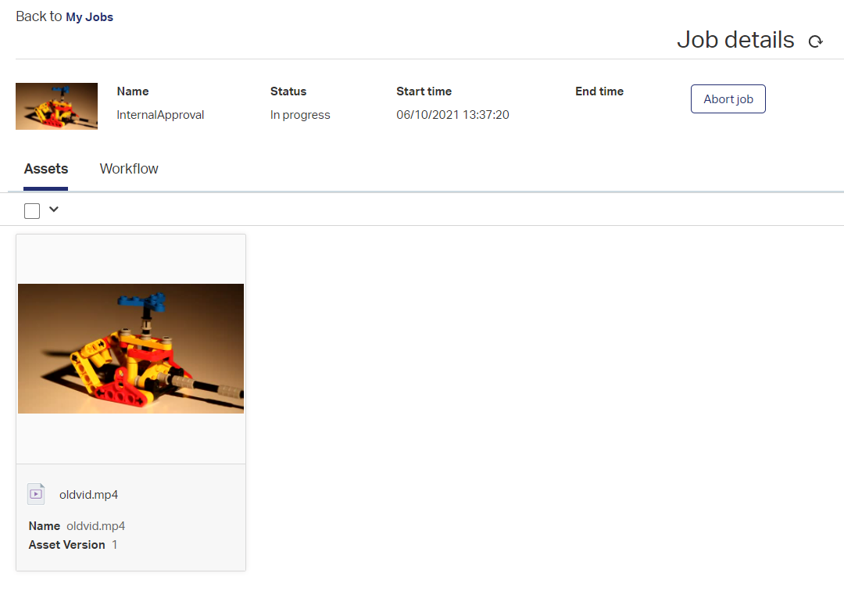

**SEARCHING**

The search options dialog box allows you to: Specify what you want to search for and where to search.

Search Suggestion - Once you type at least two characters in the search bar, Media Manager will generate a suggestion dropdown list based upon what you have typed.  The system will only generate suggestions for single words. For example, if there is an asset in the system with the name of “sunflower-from-silecia2.jpg”, and you type “sun” in the search bar, then “sunflower” will come up in the suggestion dropdown list. Since the asset has the search term “sunflower” associated with it, the file “sunflower-from-silecia2.jpg” will be displayed in the search results.

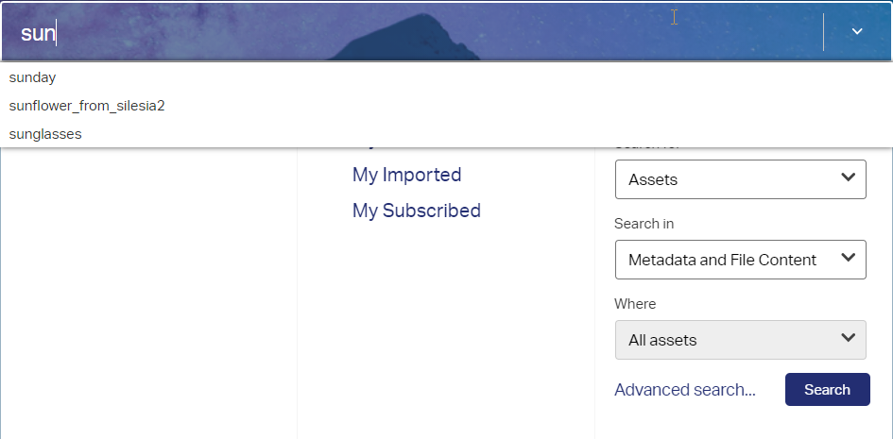

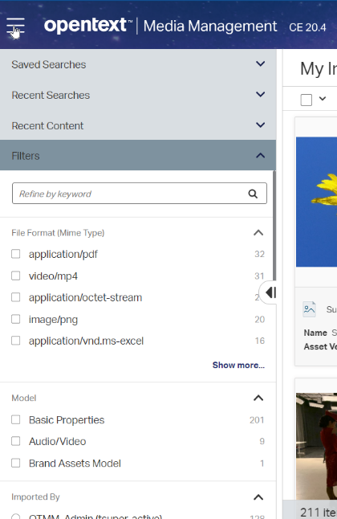Search results can be further narrowed down by using the Faceted Navigation feature. Generally speaking, a facet is a set of clearly defined, mutually exclusive properties. Facets are displayed in the Sidebar. Each Facet displayed will have a number of Facet Values displayed underneath it. Also, users can do a search within a search by typing in “Refine by keyword”.

One or more Facet Values can be selected to further narrow your search results. This will result in a new search result being created that includes assets that match your initial search criteria and which contain the selected Facet Values.

**UPLOADING ASSETS**

When uploading files, you can upload them into an existing folder.

To upload files:

Use the “Upload” widget on the Home page or add assets to an Open Folder page and perform the following steps:

Select Folders by clicking on the Hamburger Menu icon placed at the top left of the Home screen. From the folder tree, click the folder to upload your files into.

1. Select Assets from the ‘New’ dropdown, by clicking the down arrow.
2. Select a template to use from the Template dropdown. This is mandatory (as indicated by the red asterisk) before you can complete the upload. Templates, which are configured by an administrator, will apply specified metadata and security policies to each of the uploaded assets.

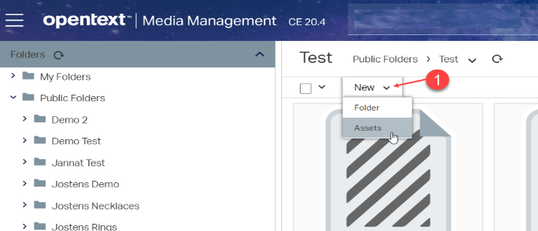

1. Optionally change the Target folder. This will default the current folder, which you can change if desired by clicking the icon and selecting another folder.
2. Optionally click the Metadata tab to configure any metadata.
3. Optionally click the Security tab to configure security policies.
4. Click Finish.

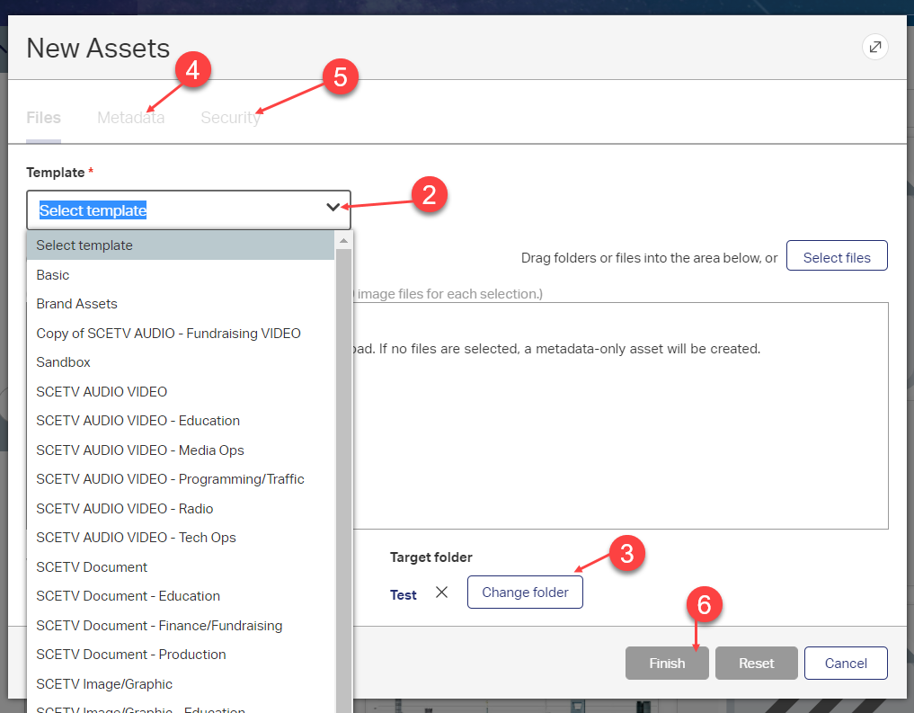

When the upload is finished, a confirmation message will appear, prompting you to update the current folder to display the new uploads

**CREATE A FOLDER**

Folders are used to group assets together. The two top-level folders consist of My Folders, which are your personal folders that are only visible to you, and Public Folders, which are folders visible subject to permissions.

To the left of a folder, click the right arrow to expand a branch or click the down arrow to collapse a branch. To display the contents of a folder, click on a folder name.

To create a new folder:

1. On the hamburger menu bar, click Folders.

When creating a new folder, it will be created underneath the currently selected folder.

1. Select Folder from the ‘New’ dropdown, by clicking the down arrow.

* Enter a name for the new folder.
* Select a folder type from the Type list.

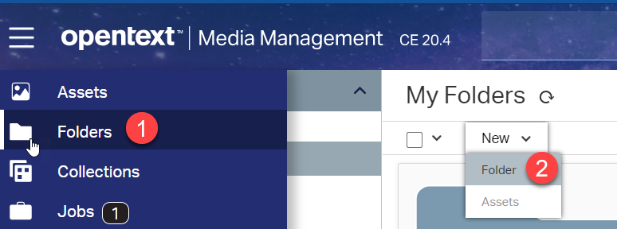

1. Click the Metadata tab to enter any metadata information.
2. Click the Security tab to select a security policy or policies to apply to the folder.

1. Click Create.

The newly created collection displays in the folder tree.

**CREATE A COLLECTION**

Collections are used to further categorize assets and store together. The collections can either be Private that are only visible to you or Share, which can be shared with multiple users.

To create a new collection:

1. On the hamburger menu bar, click Collections.
2. Click on the ‘New Collection’ label.

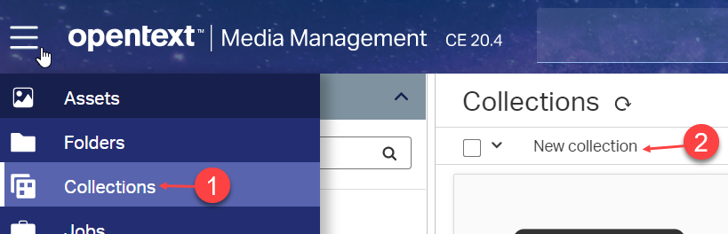

1. Select the Sharing type:

* Private (Only you)
* Share (Add the users and select Access Type from the dropdown.)

1. Click Create.

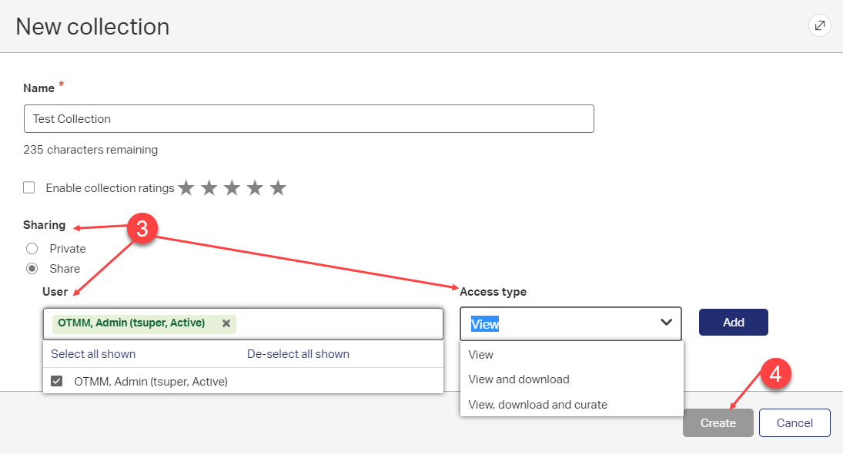

When the collection is created, a confirmation message will appear, displaying the collection has successfully been created. The newly created collection displays in the Collections panel.

**SHARING ASSETS**

To share or download assets:

Open a folder or perform a search to display the assets you want to share. Do one of the following:

1. Download Files - Direct download of the assets.
2. To share a single asset, hover the mouse over the asset so the Asset Menu appears and click the drop-down list in the Share Assets dialog box, select one of the following options and fill out the various fields (if any). Options are for transformation and delivery of assets.

